**CS 132 C# - Beginner**

**HOP01 – Data Types and Variables**

12/26/2019 Developed by Kim Nguyen

10/03/2020 Revised by Kim Nguyen

Center for Information Assurance (CIAE) @City University of Seattle (CityU)



**Before You Start**

* Version numbers may not match with the most current version at the time of writing. If given the option to choose between stable release (long-term support) or most recent, please choose the stable release rather than beta-testing version.
* This tutorial targets Windows users and MacOS users.
* There might be subtle discrepancies along the steps. Please use your best judgement while going through this cookbook style tutorial to complete each step.
* For your working directory, use your course number. This tutorial may use a different course number as an example.
* The directory path shown in screenshots may be different from yours.
* If you are not sure what to do or confused with any steps:
  1. Consult the resources listed below.
  2. If you cannot solve the problem after a few tries, ask a TA for help.

**Learning Outcomes**

Students will be able to:

* Running first C# program.
* Using character to draw simple shapes
* Declare data types and variables.

**Resources**

* C# Tutorials | W3Schools.com- <https://www.w3schools.com/cs/default.asp>
* C# Tutorials | tutorials.com- [https://www.tutorialspoint.com/csharp/](https://www.tutorialspoint.com/csharp/csharp_strings.htm)

**Create a project**

1. Open Visual Studio.
2. File > New > Project
3. Select Console App (.NET Core), click Next
4. Type “HelloWorld” in the Project name and save it in the repository you just cloned, it should be similar to below:

CS132/HOP01-YourGitHubUserName/Module1

You should see the following program autogenerated: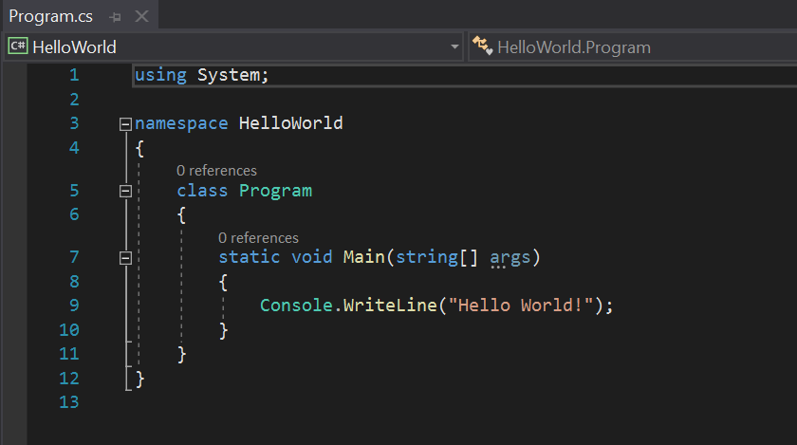

1. Let’s run the program to see what it does:

Click “HelloWorld” with the green arrow icon next to it:

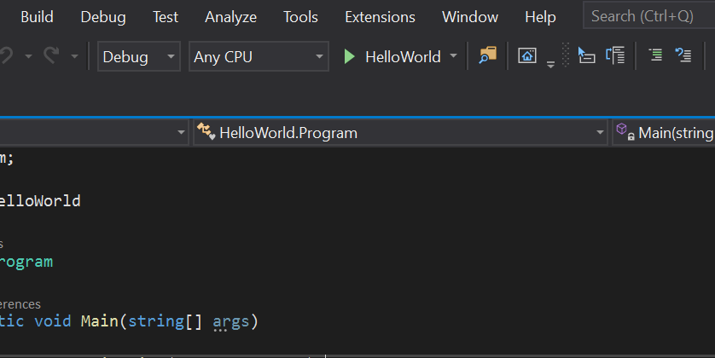

A black pop-up window should show up on your screen that says “Hello World”:

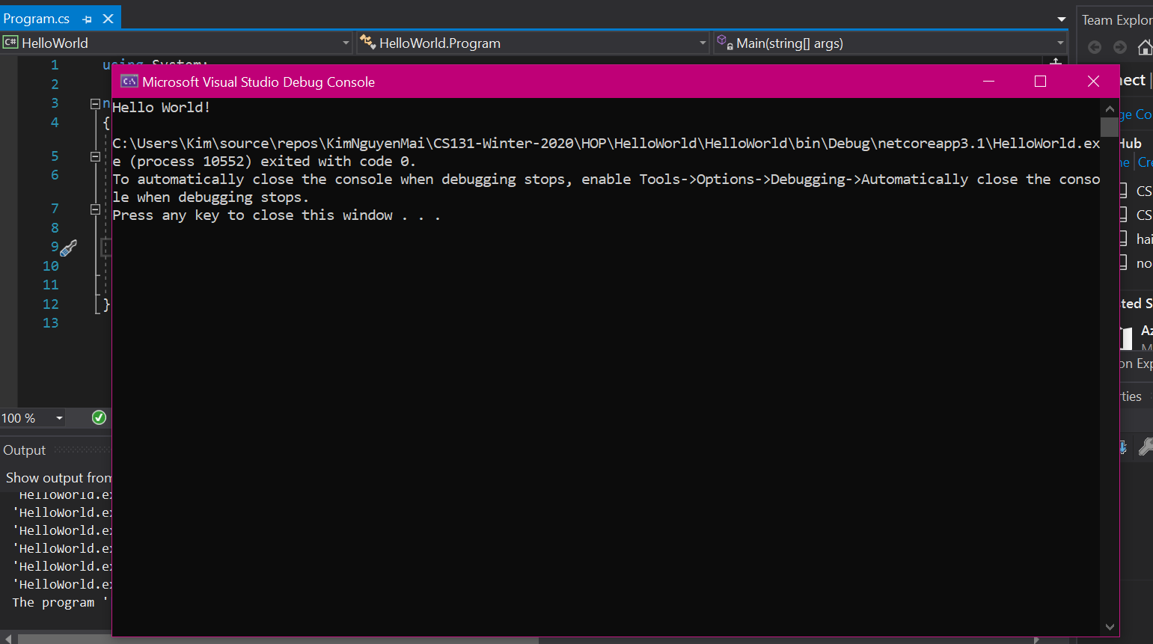

To close the window, press any key.

**Draw a shape**

6) Type the following into Program.cs

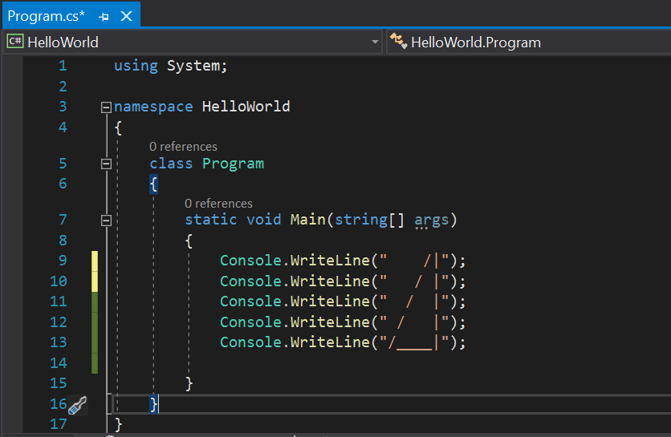

7) Run the program again, you should see a triangle printed on the screen:

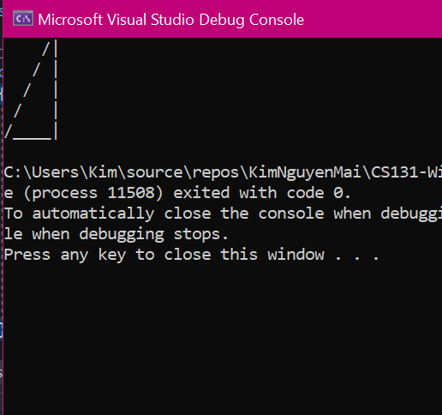

**Data Types:**

8) Type the following into Program.cs:

(Change “Kim” to your name and “25” to your Age)

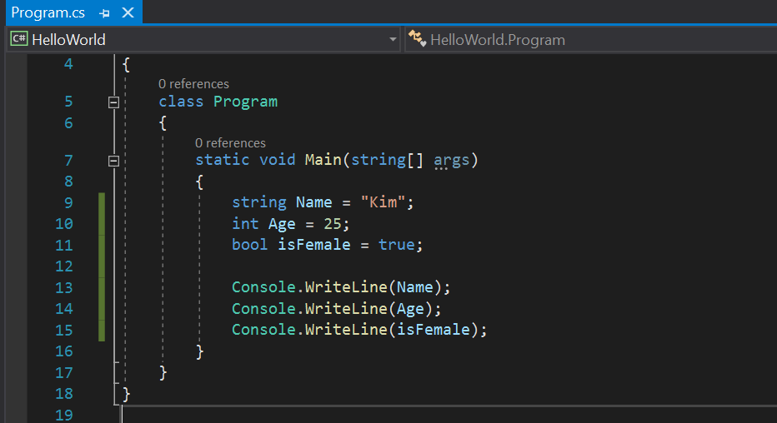

9) Let’s run the program to see what it does:

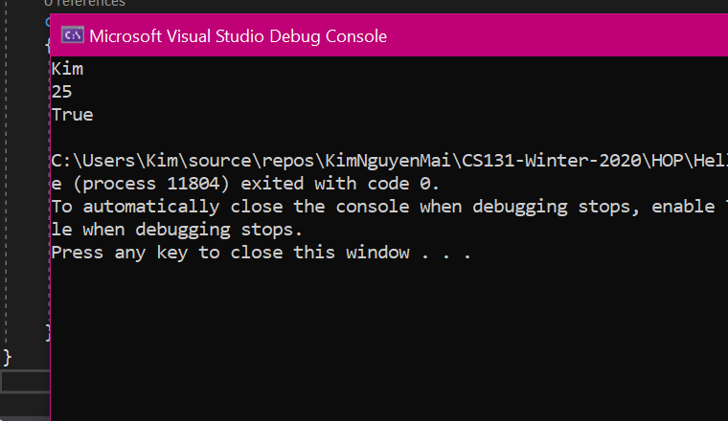

**String**:

Strings are used for storing text. A string variable contains a collection of characters surrounded by double quotes.



**Boolean**: Very often, in programming, you will need a data type that can only have one of two values, like:

YES / NO

ON / OFF

TRUE / FALSE

For this, C# has a bool data type, which can take the values true or false. 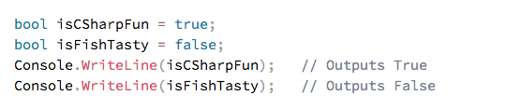

**Variables**:

Variables are containers for storing data values.

In C#, there are different types of variables (defined with different keywords), for example:

int - stores integers (whole numbers), without decimals, such as 123 or -123

double - stores floating point numbers, with decimals, such as 19.99 or -19.99

char - stores single characters, such as 'a' or 'B'. Char values are surrounded by single quotes

string - stores text, such as "Hello World". String values are surrounded by double quotes

bool - stores values with two states: true or false

<https://www.w3schools.com/cs/cs_variables.asp>

**Challenge**:

Create a variable named “MyFloat” of type float that has the value of “10.1” and print it on the screen. Expected result:

